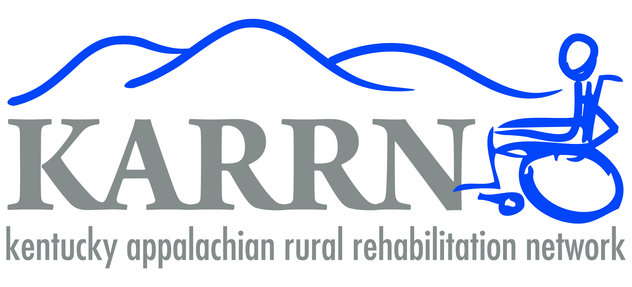
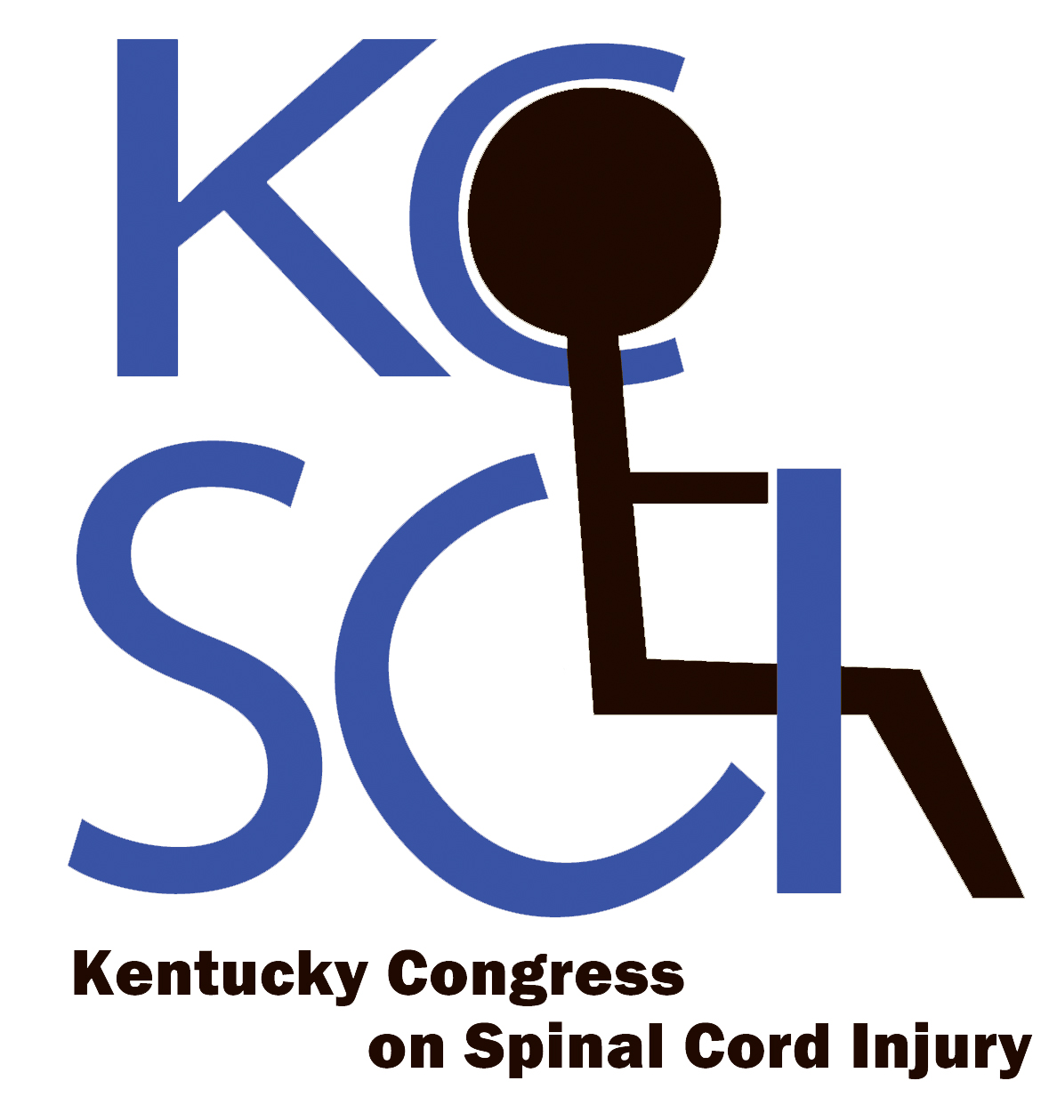
SAVE THE DATE
4th Annual Kentucky Congress on Spinal Cord Injury (KCSCI)
“An accessible Kentucky for all”
September 15th, 2016 from 9:00 AM to 4:00 PM
Cardinal Hill Rehabilitation Hospital - Center for Learning, Lexington, KY
Need:
Organizations, outreach programs and specialized medical care providers for individuals living with chronic spinal cord injury (SCI) in the Commonwealth of Kentucky have traditionally been unorganized and without a common mission. Importantly, while current outreach efforts appear to have some impact for SCI individuals in urban areas, we wish to build cohesion among this community of individuals throughout the commonwealth by expansion into the more rural areas. We envision congress participants, sponsors, healthcare providers and care givers all exchanging information about programs available to those in need throughout the commonwealth. The community of individuals with SCI and their support systems can be a strong advocacy group given the right organizational structure.
Mission:
The mission of the Kentucky Congress on Spinal Cord Injury (KCSCI) is to gather individuals with SCI from around the commonwealth to join in the discussion of critical issues that are important to them and to help draft agendas to be used to legislate changes in our commonwealth for people with SCI. The members of the KCSCI should be strong advocates for the rights of all people with disabilities and be willing to provide peer mentoring for newly injured folks who may need additional support.
Agenda:
Come join the discussions about how we can work to make Kentucky the most accessible state possible. Listen to experts talk about ways we can motivate government and private industry to continue improving accessibility. Learn about the importance of voting by members of the largest minority group in Kentucky – people with disabilities. See the latest in disability-related innovation from companies like Superior Van & Mobility, Braun, Bruno, AlterUREGO, and more. Come see the presentation of the inaugural KCSCI Tom Gravitt Advocacy Award. Eat some BBQ and get a free t-shirt. Most importantly, find out how YOU can impact the lives of the SCI community as we plan a platform for 2016-17.
**REGISTRATION for this FREE event will be open July 21.
Register beginning July 21 at http://tinyurl.com/KCSCI-2016

For more information you can contact the KCSCI at KCSCI@twc.com or Visit our Facebook page at https://www.facebook.com/KCSCI

