Natural Reader Instructions

1. **Go to** [**https://www.naturalreaders.com/online/**](https://www.naturalreaders.com/online/)**.**

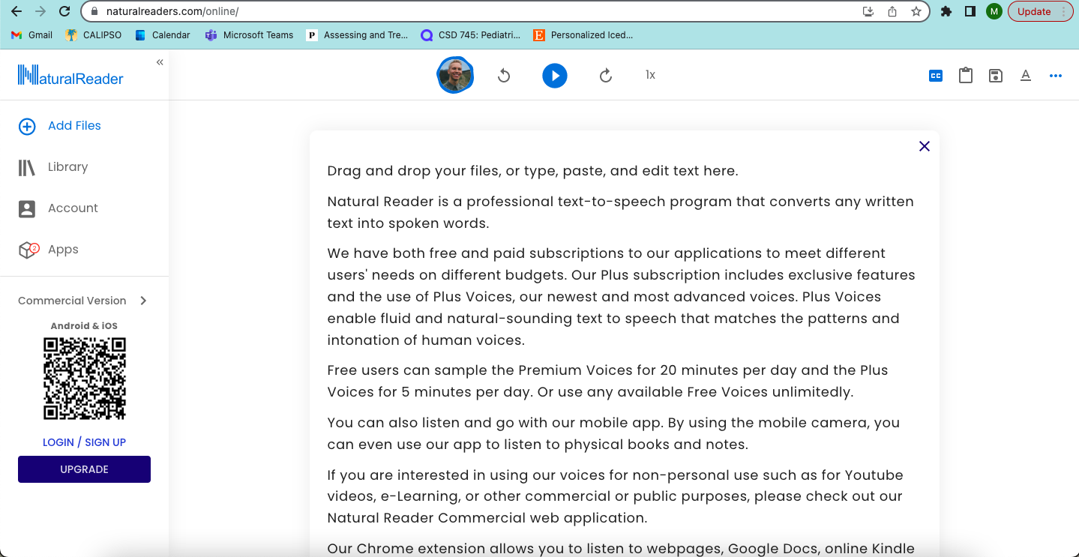

1. **Copy desired reading material from source.** 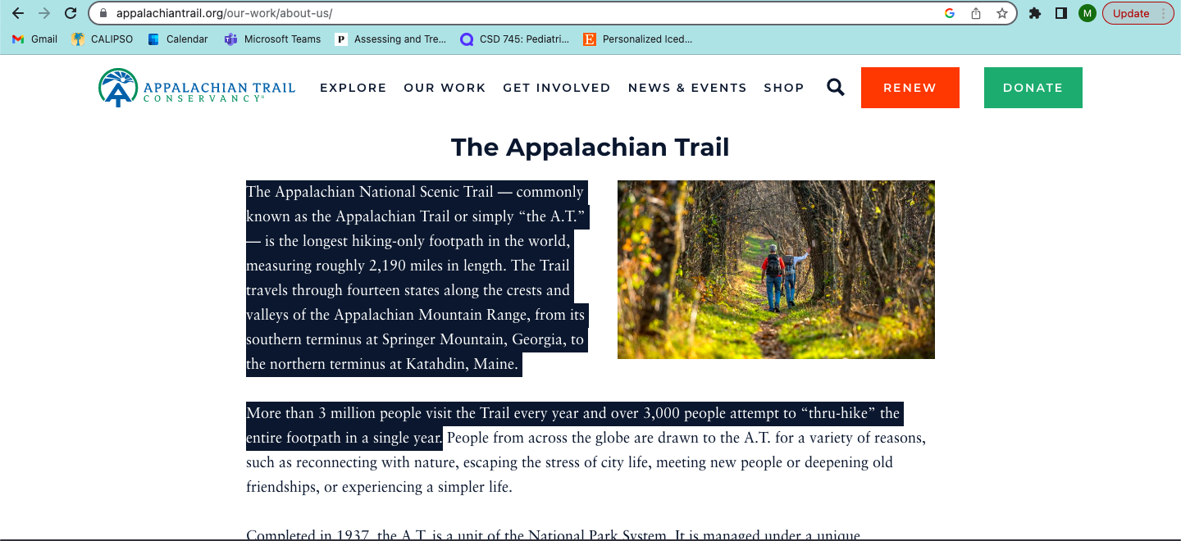
2. **Paste reading material into the Natural Reader by clicking on “add files” and then “text.”**

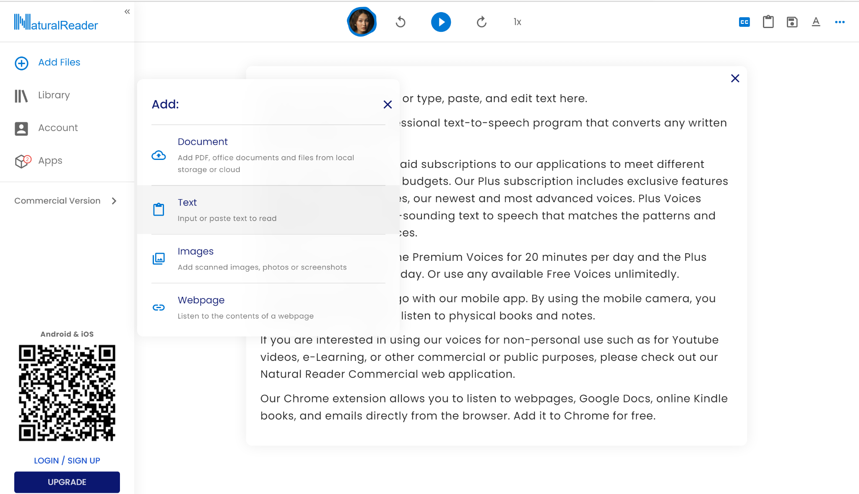

1. **All reading material will be in your “library”**
2. **Click on “library” to choose one of your reading materials**

**6. Press blue play button to start reading**

**7. Adjust settings as needed:**

* **Change speed (as shown below)**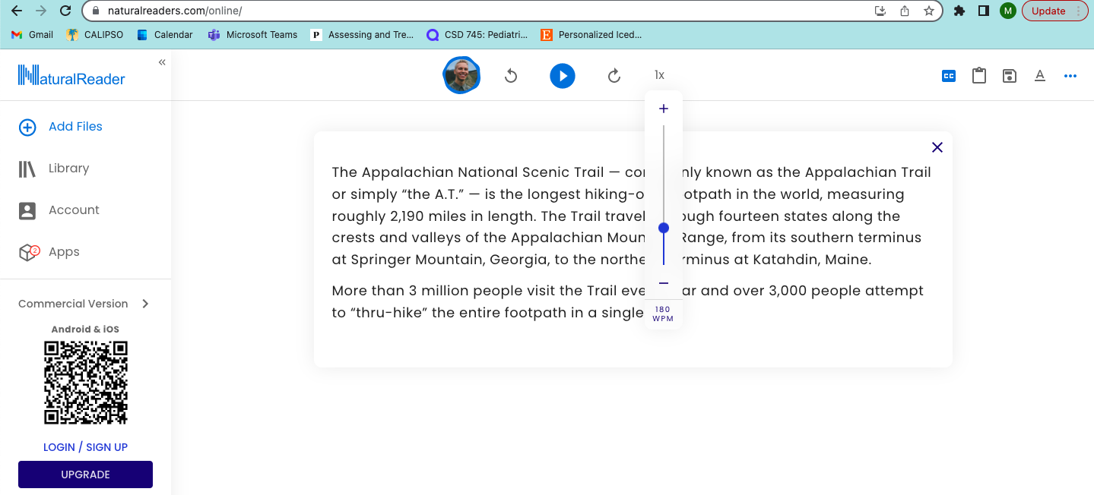
* **Text Highlight Color to follow along with reading (as shown below)**

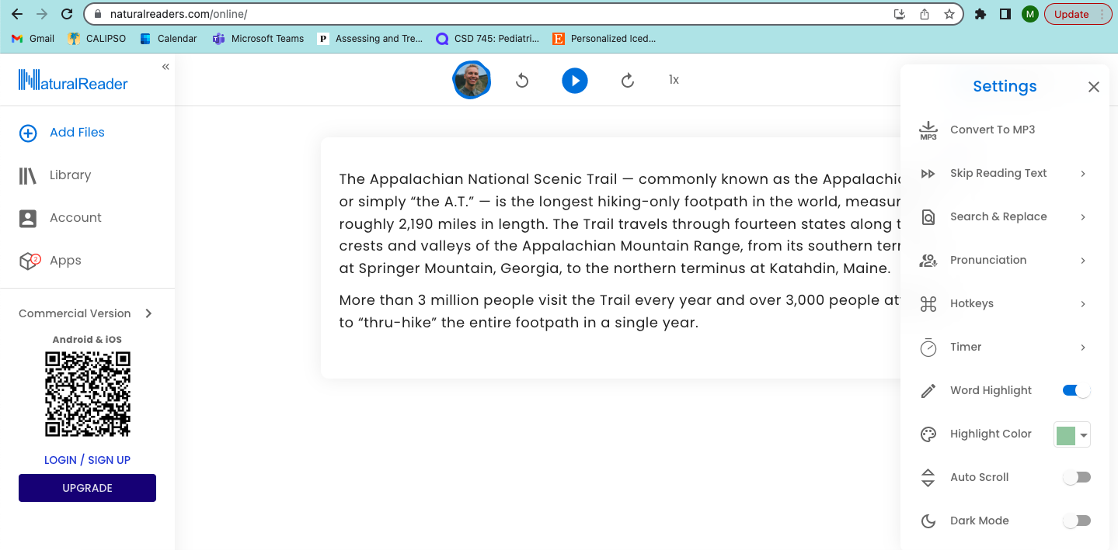

Natural Reader FAQ: <https://www.naturalreaders.com/personalwebfaq.html>

With this link, you can also contact technical support if needed.