PhraseExpress Steps for iPhone

Adding PhraseExpress to Apple Keyboard:

1. Download PhraseExpress from app store.

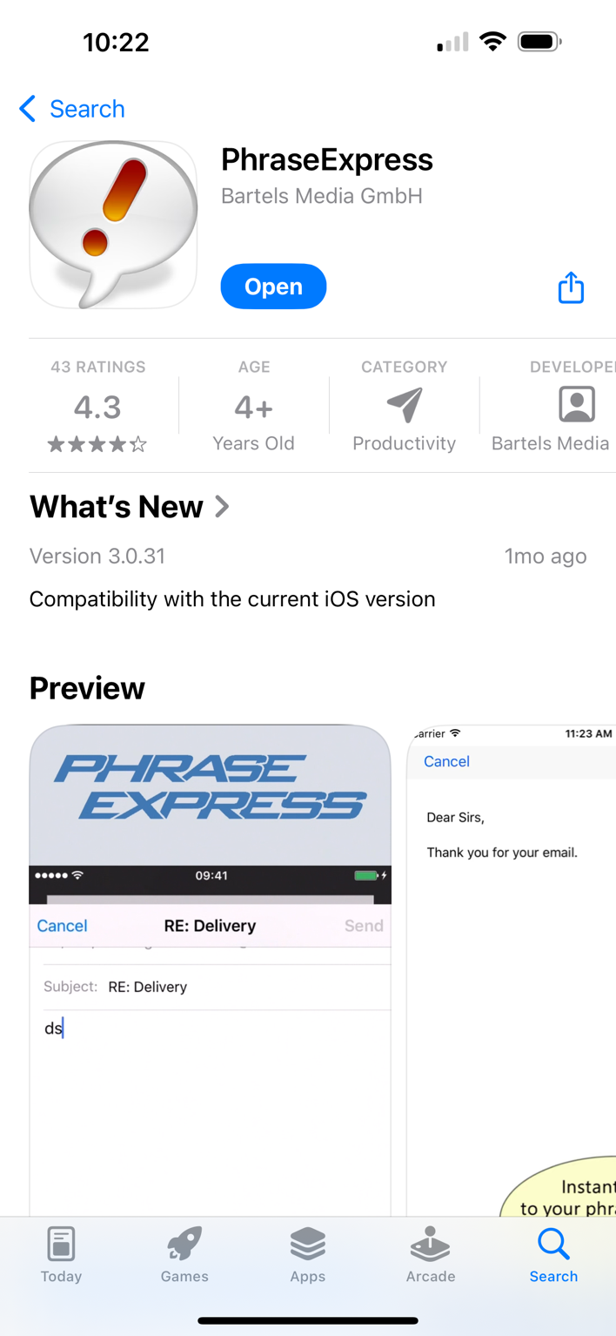

1. Go to Settings.

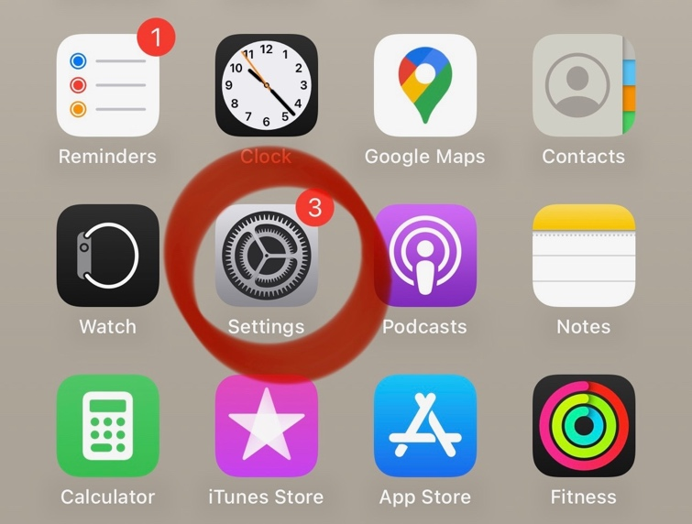

1. Select “General.”

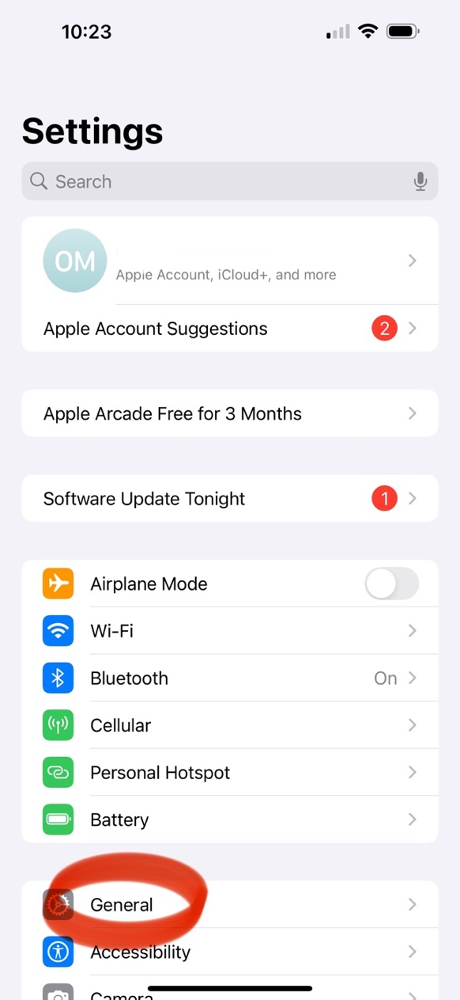

1. Select “Keyboard.”

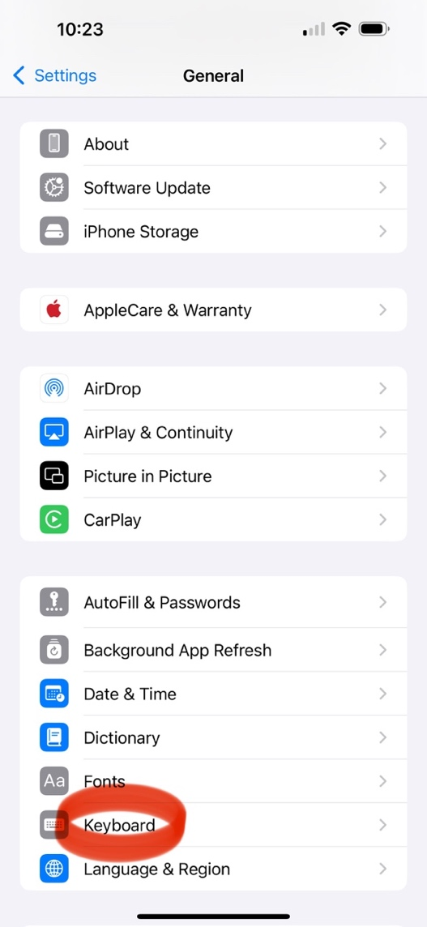

1. Select “Keyboards.”

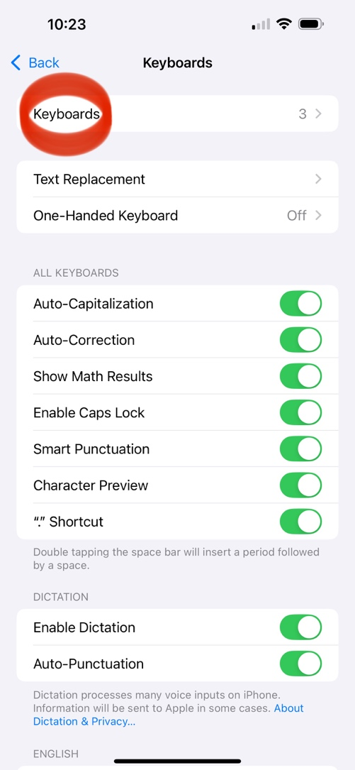

1. Select “Add New Keyboard.”

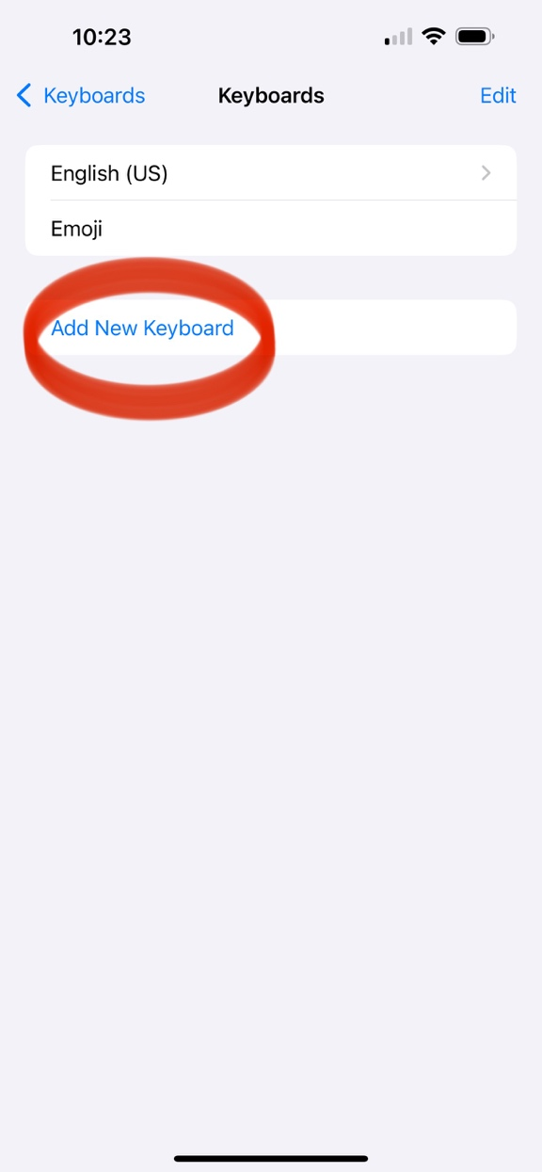

1. Select “PhraseExpress.”

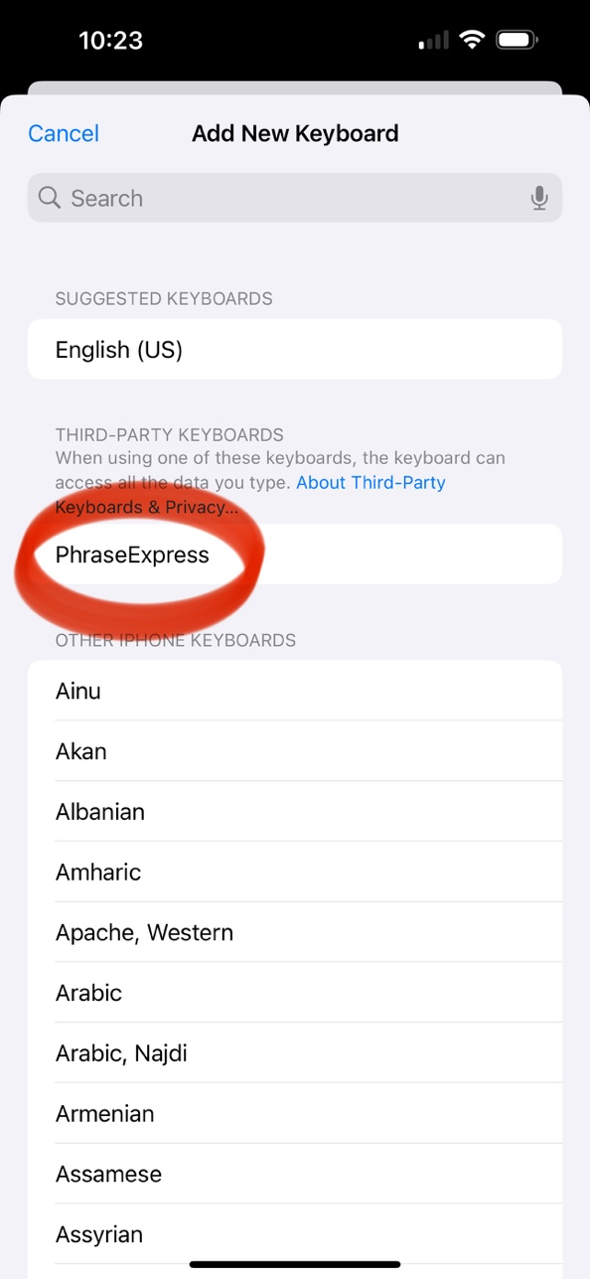

1. Enable “PhraseExpress English.”

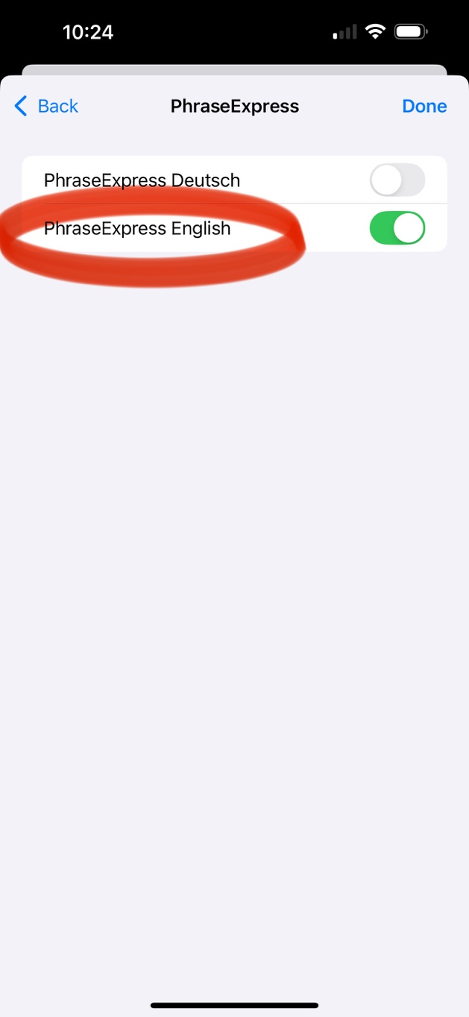

1. Tap “PhraseExpress English.”

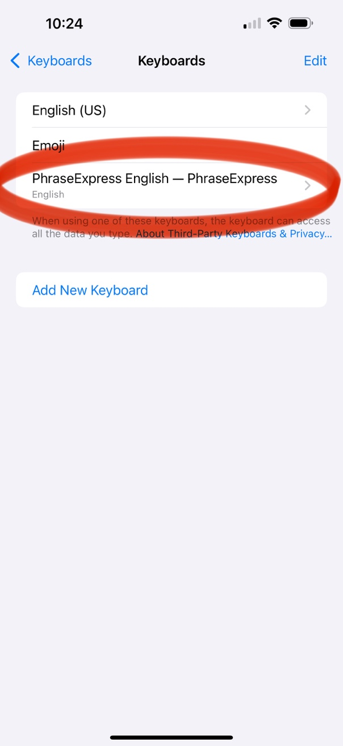

1. Enable “Allow Full Access.”

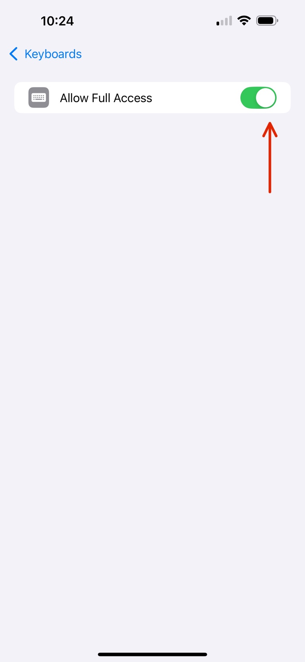

Adding Desired Phrases:

1. Go to PhraseExpress app.
2. Select the “+” in the bottom right corner.

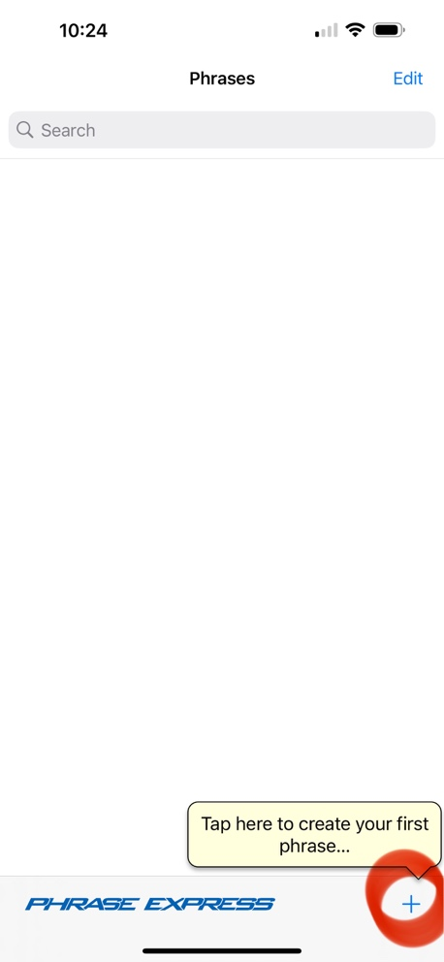

1. To add a new folder for phrase categories, select “new folder.”

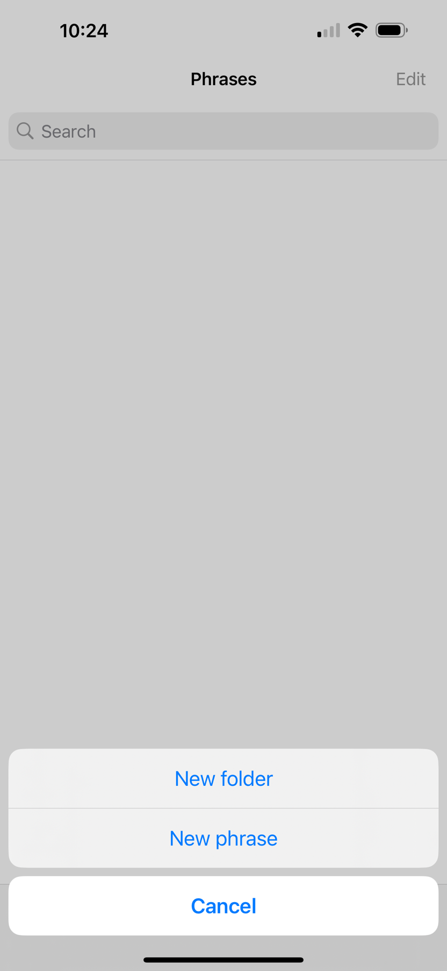

1. To add a new phrase, select “new phrase.”

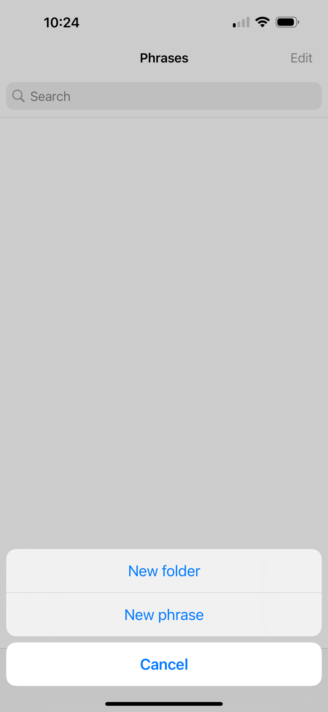

1. Type desired phrase into “description” box.

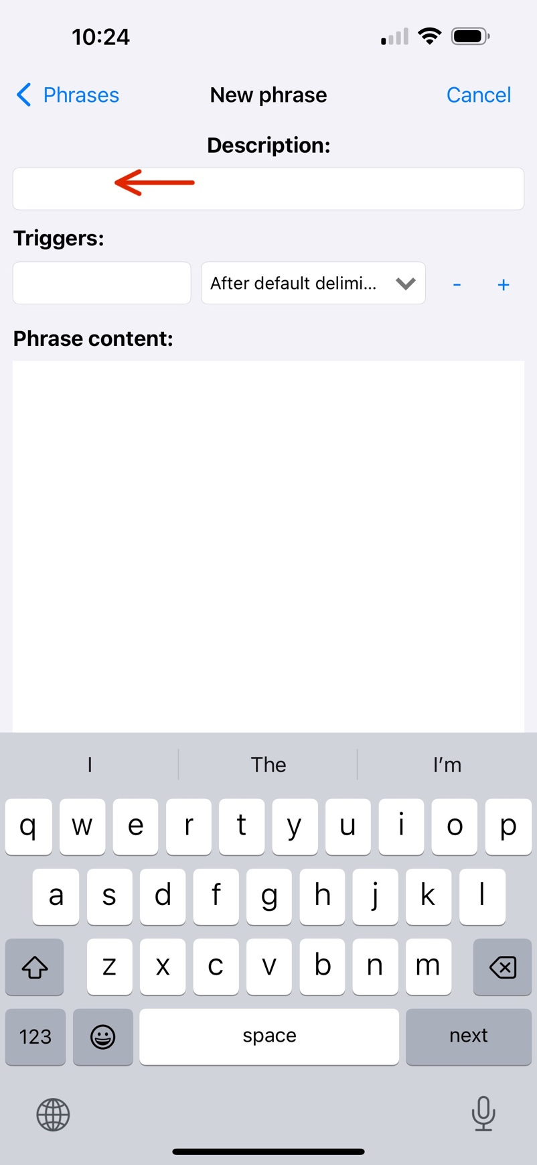

1. Press “done.”

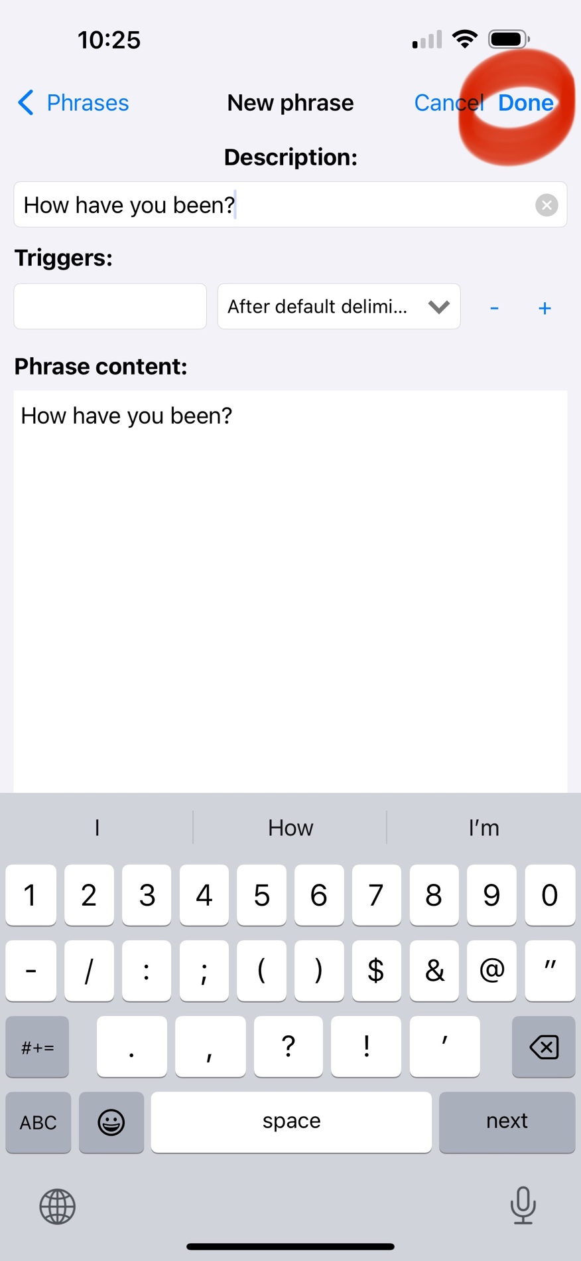

1. Repeat the process to add as many desired phrases.

Accessing Phrases from Apple Keyboard:

1. Press and hold globe icon on Apple keyboard on the bottom left corner.

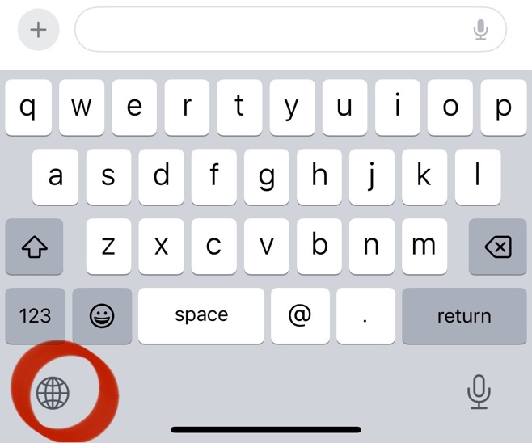

1. Select “PhraseExpress English.”

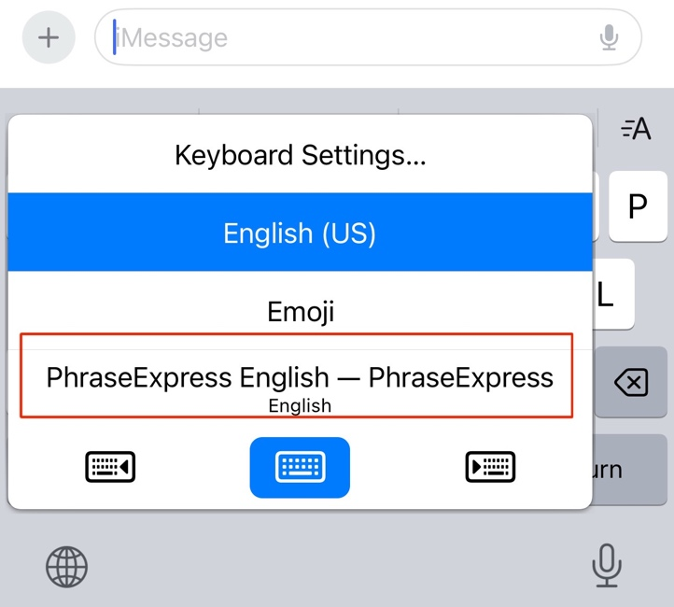

1. Select red exclamation icon.

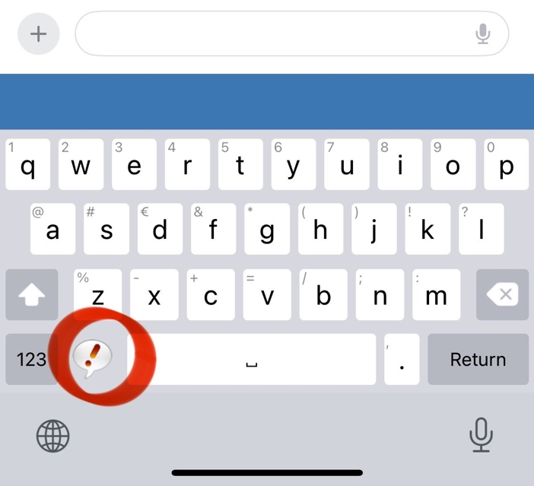

1. Select desired phrase.

